Homework #3 Chapter 9 plus Sequence Diagram

# CINS 370 Introduction to Databases Due Friday February 17, 11:59pm 70 points

1. Do Exercise 9.3 (The book has a typo. It pertains to Figure 6.6 and not Figure 6.14.)
2. Do Exercise 9.5
3. Do the Sequence Diagram exercise that is included below.
4. As with all HW, any diagrams should be created using a graphical tool. The **draw.io** and **Lucidchart.com** are popular free app. In other words, do not scan hand-written work. Thanks.

9.3 - Map the relational schema of **Figure 6.6** into an ER schema. This is part of a process known as reverse engineering, where a conceptual schema is created for an existing implemented database. Include cardinality notation with all relationships by stating any assumptions you make.

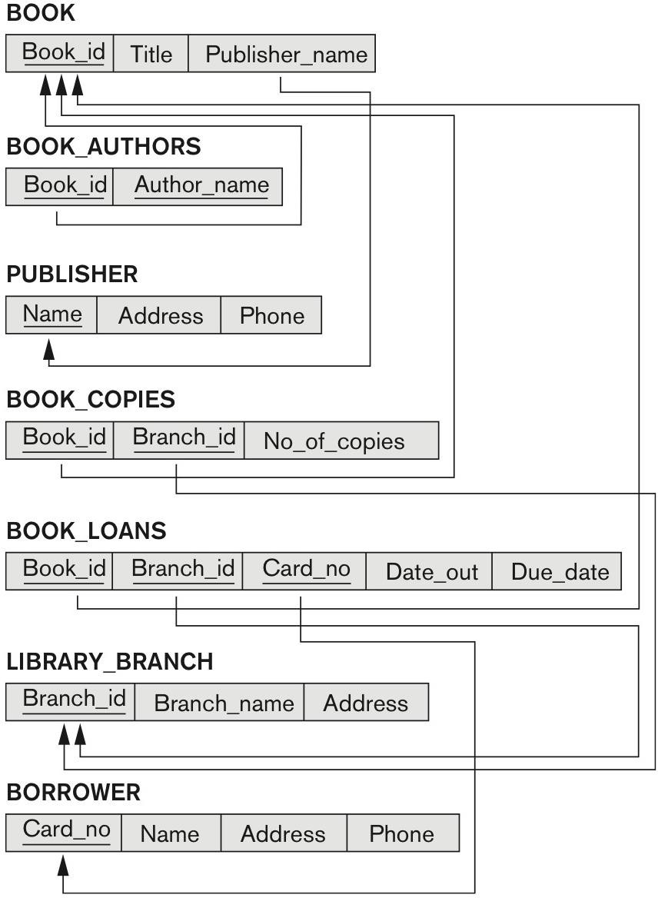

**Figure 6.6** A relational database schema for a LIBRARY database.

### THE FOLLOWING IS INCLUDED TO OFFER AN EXAMPLE ON HOW TO COMPLETE 9.5

9.4 - Figure 9.8 shows an ER schema for a database that may be used to keep track of transport ships and their locations for maritime authorities. Map this schema into a relational schema, and specify all primary and foreign keys.

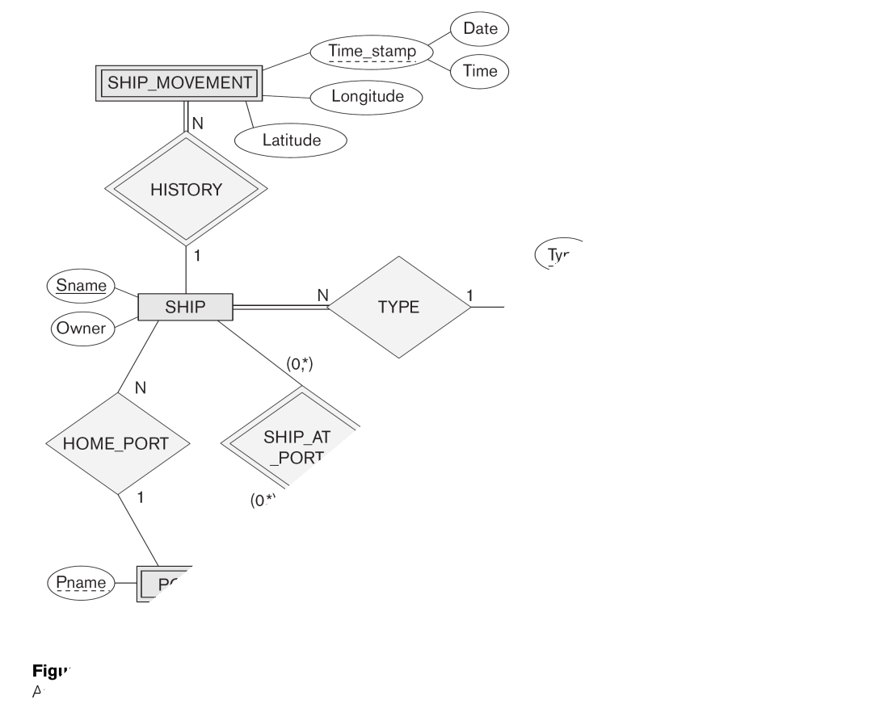

# Answer:

## SHIP

SNAME OWNER TYPE PNAME FK FK

## SHIP_TYPE

TYPE TONNAGE HULL

## STATE_COUNTRY

NAME CONTINENT

## SEAOCEANLAKE

NAME

## SHIP_MOVEMENT

SSNAME DATE TIME LONGITUDE LATITUTE FK

## PORT

S_C_NAME PNAME S_O_L_NAME FK FK

## PORT VISIT

VSNAME VPNAME STARTDATE ENDDATE FK FK

9.5. Map the BANK ER schema of Exercise 3.23 (shown in Figure 3.21 below) into a

relational schema. Specify all primary keys and foreign keys. Follow the similar example as 9.4 stated above.

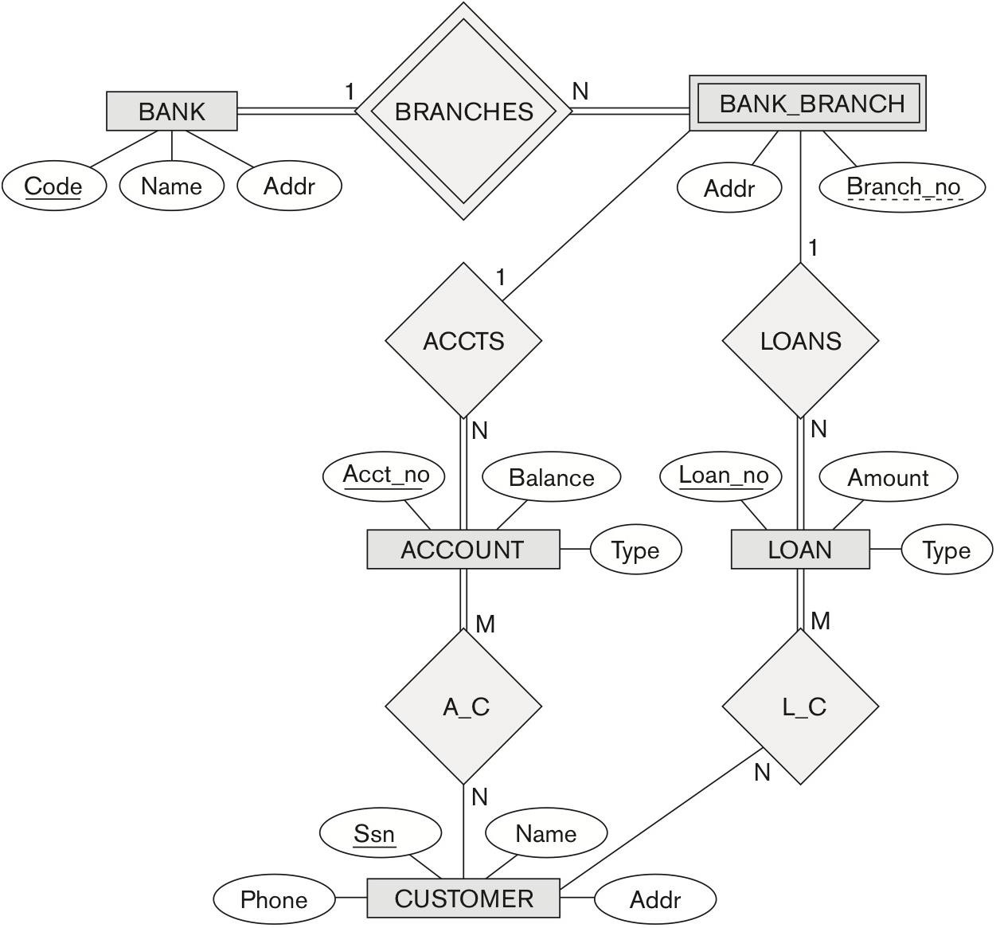

**Figure 3.22** An ER diagram for a BANK database schema.

1. Refer to the Sequence Diagram shown below. Modify the diagram as follows:
   1. Remove the 2nd Little Pig and Stick House
   2. Remove the Pot of Water
2. The 1st Little Pig should run to the Brick House once his house is blown (Note: the brick house needs to have been built already).
3. The 3rd Little Pig accidentally shoots and misses when the 1st Little Pig enters
4. The 1st and 3rd Little Pig bind/tie up Wolf after Wolf climbs down chimney

Some additional notes.

1. There is no need to represent a gun (shooting instrument) and rope (binding instrument) as objects.
2. Concurrent events need to share the same horizontal line.
3. It is appropriate to have arrows from right to left.

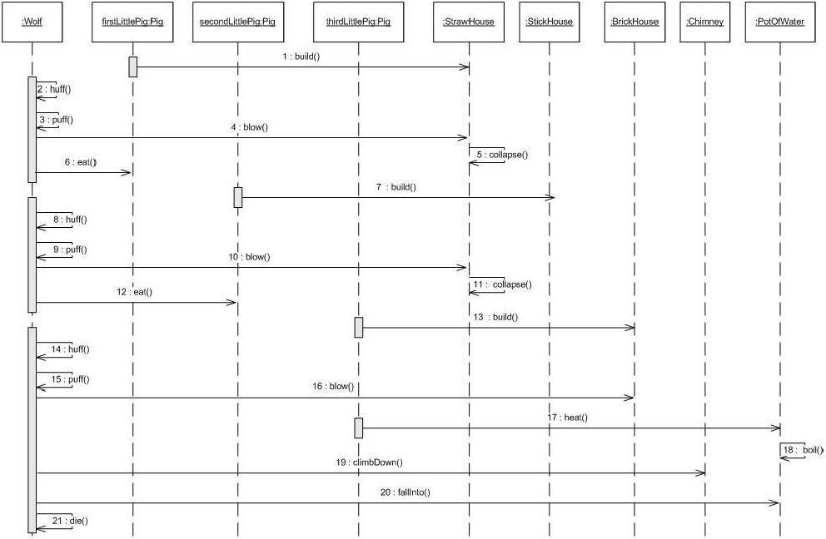

### Submission Steps

Using our class textbook, turn in answers via Blackboard. Hand-written work is not accepted.

Submit only 1 Word/PDF formatted file on Blackboard. Grading will be done on content, correctness, neatness, grammar, timeliness, etc. Please refer to our course syllabus for more submission details.

Please email instructor for any question(s). Keep in mind that if you send your email within 2-3 days before the due date, you may not get a reply on time. This is an incentive to start and complete your work early.